SIFT Codage
We used the sift.detectAndcompute() function of Opencv in python which is composed by sift.detect() for find the key-points and sift.compute() for calculate the descriptors from the key-points. We added some options to allow the program to scan whole the database, calculate the sift descriptors of each image and save them on a txt file.
SIFT test
In this stage, the goal is to apply different transformation on an image. Then calculate the descriptors on each image by using the SIFT algorithm in order to check the invariance of the SIFT descriptor to the rotation, luminosity and the scale changes.
On the following images, we can see the results obtained.
Illustration 1: key-points on the original image

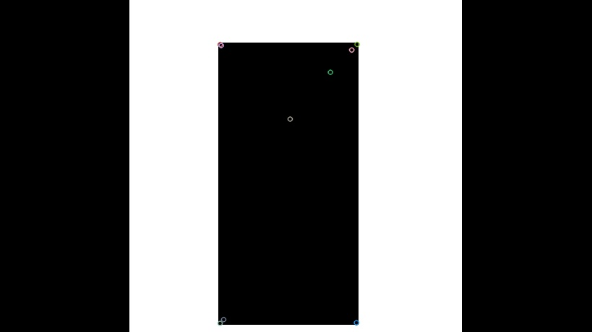Illustration 2: key-points after rotation

Illustration 3: key-points after scale change

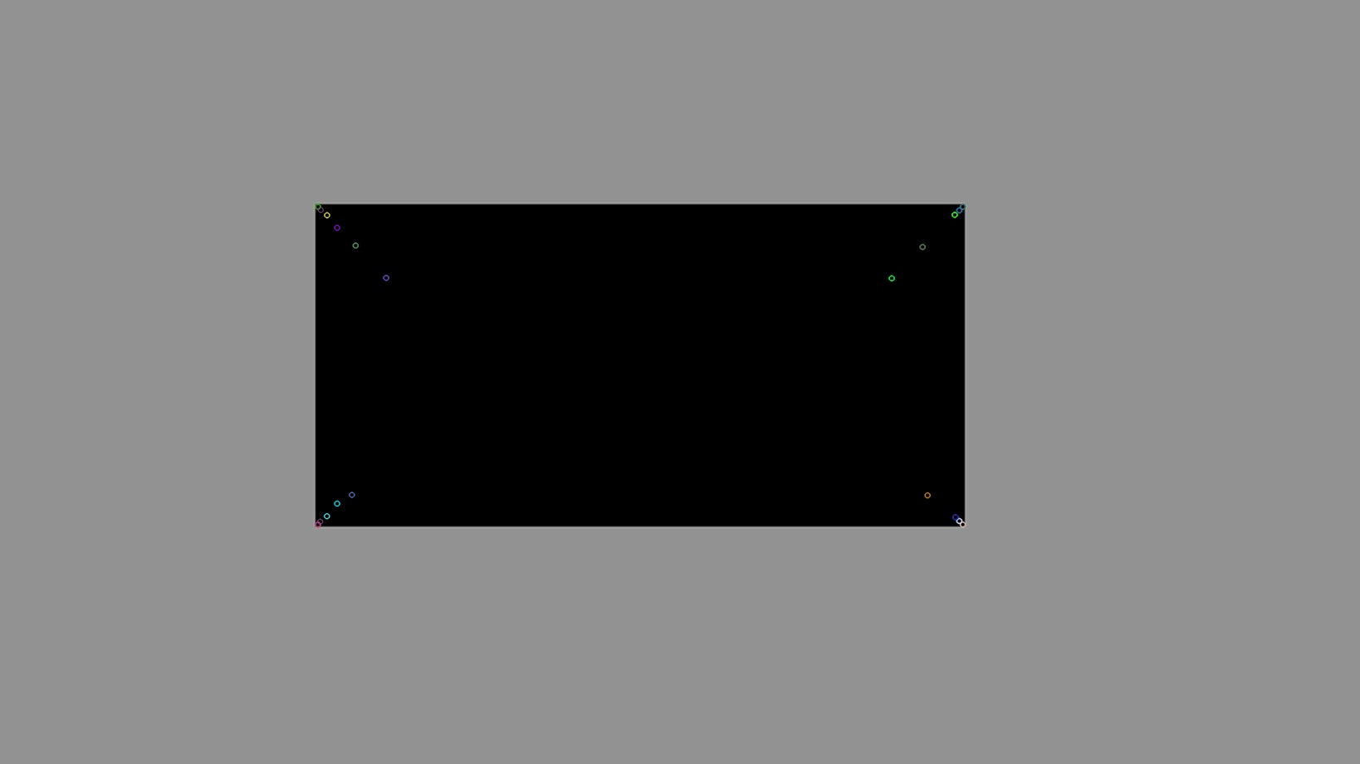Illustration 4: key-points after luminosity change

The results show that whatever the transformation we have same key-points but some of them are in different positions according to the transformation.
We can confirm that the sift descriptor is invariance to the rotation, the luminosity and the scale changes.

